,-artycxGl my bois

1q` aZx ç 0, 1

* 2. + - R is reflexive $∀a∈A (aRa)$
       - R is symmetric $∀a,b∈A (aRb ⇒ bRa)$
       - R is transitive $∀a,c∈A (∃b∈A (aRb ∧ bRc) ⇒ aRc)$
     1. $R = \left\{<1, 2>, <2, 1>\right\}$ is symmetric but not reflexive.
        + Take R and S, two arbitrary symmetric relations.
        + Assume that their union $R∪S$ contains <a, b> with a and b arbitrary.
        + $a R∪S b = aRb ∨aSb$ (def. of $∪$)
        + $aRb ∨aSb ⇒bRa ∨bSa$ (R and S are symmetric)
        + $bRa ∨bSa =b R∪S a$ (def. of $∪$)
        + We’ve shown $a R∪S b ⇒ b R∪S a$. Therefore, $R∪S$ is symmetric.

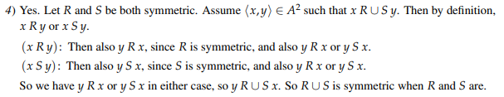

* + 1. - Take R and S, two arbitrary transitive relations.
       - Assume that their intersection $R∩S$ contains <a, b> and <b, c> with a, b and c arbitrary.
       - $a R∩S b ∧b R∩S c = aRb ∧ aSb ∧ bRc ∧ bSc$ (def. of $∩$)
       - Since $∧$ is commutative, we get $aRb ∧ bRc ∧ aSb ∧ bSc$
       - By transitivity of R and S we have $aRc ∧aSc$
       - $aRc ∧aSc =a R∩S c$ (def. of $∩$)
       - Therefore, $R∩S$ is transitive.

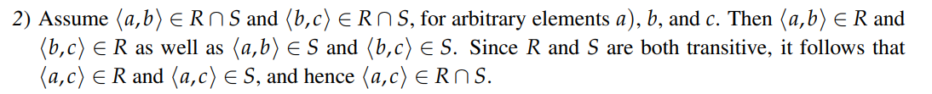

* + 1. - is transitive. - this isnt transitive is it?? Its missing <2, 2>. You are right, <2, 2> is missing.
       - $S = \left\{<2, 3>, <3, 1>, <2, 1>\right\}$ is transitive.
       - $R∪S =\left\{<1, 2>, <2, 1>, <1, 1>, <2, 3>, <3, 1>, <2, 1>\right\}$ which is not transitive since it contains <1, 2> and <2, 3> but not <1, 3>.

Another example:

* + - * R = {<1, 2>} is transitive
      * S = {<2, 1>} is transitive
      * RUS = {<1, 2>, <2, 1>} is not transitive because it is missing <1, 1> and <2, 2>
  1. i.

ii.

* 1. Assume a symmetric set R. 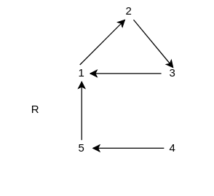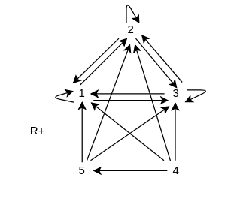

Then, if we have

$$aRb∧bRc => aR²c$$

We also have

$bRa∧cRb => cR²a$*(by commutativity of $∧$)*

Therefore R² is symmetric.

Therefore, for any symmetric ${R, R}^{}○R$ is symmetric.

Therefore, for any symmetric $R^{n}, R^{n}○R =R^{n+1}$ is symmetric.

So if R is symmetric, $R^{n}$ is symmetric for any natural n, including $R^{+}$

*Dodgy af but the idea is kind of induction over the transitivity of $R^{n}$* . *I’m sure there’s a better way to write it down.*

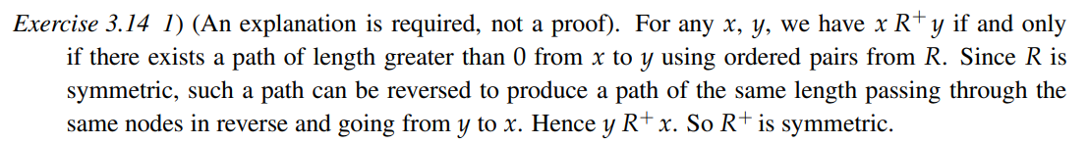

Alt d. Take arb a, b∈A s.t. a R+ b

By def of R+, a(R $∪$ R^2 $∪$ R^3 $∪$...)b

aRb | aR^2b | aR^3b |..

To prove, for all n ∈ Nat+, R^n is symmetric

Base case : When n = 1, R is symmetric (by def)

Inductive case: Assume R^n is symmetric, let S = R^n

Take arb a, b∈A s.t. a(S o R)b

Therefore Ǝc∈A[aSc ^ cRb]

As S and R are both symmetric, Ǝc∈A[cSa ^ bRc]

Therefore b(S o R)a, which means (S o R) is symmetric, hence R^(n+1) is symmetric.

By Induction, for all n ∈ Nat+, R^n is symmetric.

Therefore bRa | bR^2a |bR^3a |..

By def of R+, b R+ a

Hence R+ is symmetric.

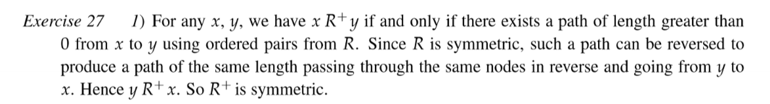

* 1. i. In order for a relation R to be an equivalence relation, it should be symmetric, reflexive and transitive.

ii. $"⇒"$ (reflexive + circular => equivalence)

* R is circular = $∀ a, c ∈ A (∃ b ∈A ( aRb ∧ bRc) ⇒cRa)$
* Take $aRb, then aRa ∧ bRb.$ (R is reflexive)

To show: R is symmetric and transitive.

I. Symmetry:

$∀ a, b ∈ A (aRb ∧$ bRb $⇒$ bRa) (R is symmetric)

II. Transitivity:

$∀ a, c ∈ A (∃ b ∈A ( aRb ∧ bRc) ⇒cRa)$ (because circular)

By symmetry, $∀ a, c ∈ A (cRa ⇒aRc)$

So, R is transitive.

R is reflexive, symmetric and transitive, thus it is an equivalence relation on A.

$"⇐"$ (equivalence => reflexive + circular)

* R is reflexive:

True, equivalence implies reflexivity.

* R is circular:

$∀ a, c ∈ A (∃ b ∈A ( aRb ∧ bRc) ⇒aRc)$ (transitivity)

$∀ a, c ∈ A (aRc ⇒cRa)$ (symmetry)

$∀ a, c ∈ A (∃ b ∈A ( aRb ∧ bRc) ⇒cRa)$ (tran. + sym.)

So, R is circular

* + 1. R is a pre-order if it is reflexive and transitive.
    2. R is anti-symmetric = $∀ a, b ∈A (aRb ∧ bRa ⇒a = b)$
    3. R is a partial order if it is reflexive, transitive and anti-symmetric.
    4. R is irreflexive = $∀ a∈A (¬ aRa)$
    5. R is a strict partial order if it is irreflexive and transitive.
    6. R is a total order is a partial order that also satisfies

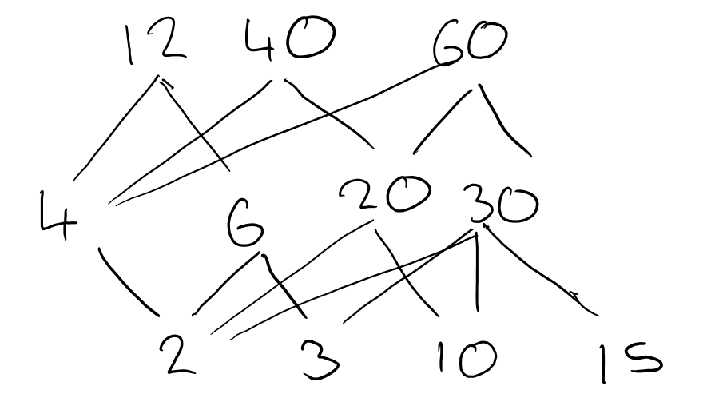

* + 1. **Since not reflexive (1 is not in F so K cannot be 1)9**

**A false, B True, C False, D True, E True, F False**

* 1. z
     1. The relation “~” between sets A and B (A ~ B) means that there exists a bijection f: B -> A.Le
     2. 